Linear Gate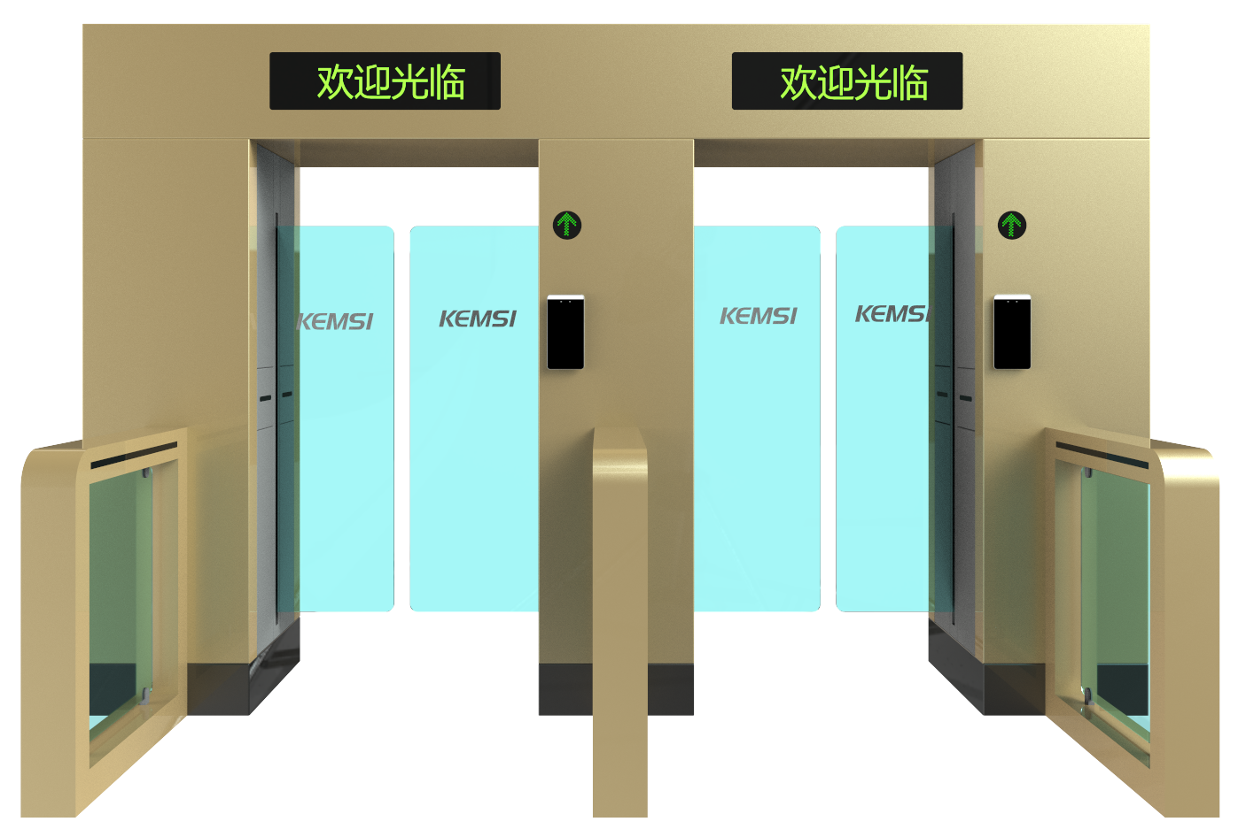

Product Description: The KMS-P3721 sliding gate is a high-tech product designed for intelligent management of personnel access channels, representing an upgraded version of the smart three-roll barrier. Featuring precision engineering, comprehensive functionality, and premium quality, it is primarily used in upscale residential communities, smart buildings, hotels, subway systems, ports, clubs, and other high-end venues. This equipment seamlessly integrates mechanical, electronic, and microprocessor controls with various identity recognition technologies, supporting compatibility with IC cards, ID cards, barcode cards, fingerprint scanners, and other card readers. By incorporating optional identity verification systems along with reliable security protection devices, alarm mechanisms, and directional indicators, it enables coordinated intelligent control and management of access channels.

technical parameter ：
product model | KMS-P3721
Case material | 304 stainless steel/201 stainless steel with baked paint finish; lid thickness: 1.5 mm; body thickness: 1.2 mm
Standard chassis dimensions | 3740*800*2400mm
infrared | 6 pairs (Brand: Jietek)
source | 24V 8.5A (Brand: Mingwei)
gangway width | 550–1000 mm (double-sided)
Arm swing material | Acrylic swing door
working voltage | AC220V±10%/50HZ
Drive Motor | 24V brushless DC motor (Brand: Lianyi)
Passage Speed | 20–30 people per minute
end-use temperature | -10°C to 70°C; Relative humidity: ≤90%; No condensation
Input Interface | Relay dry contact signal or a 12V pulse signal with a pulse width ≥100 ms
CI | RS485 standard: Distance ≤300 meters

outline dimension ：

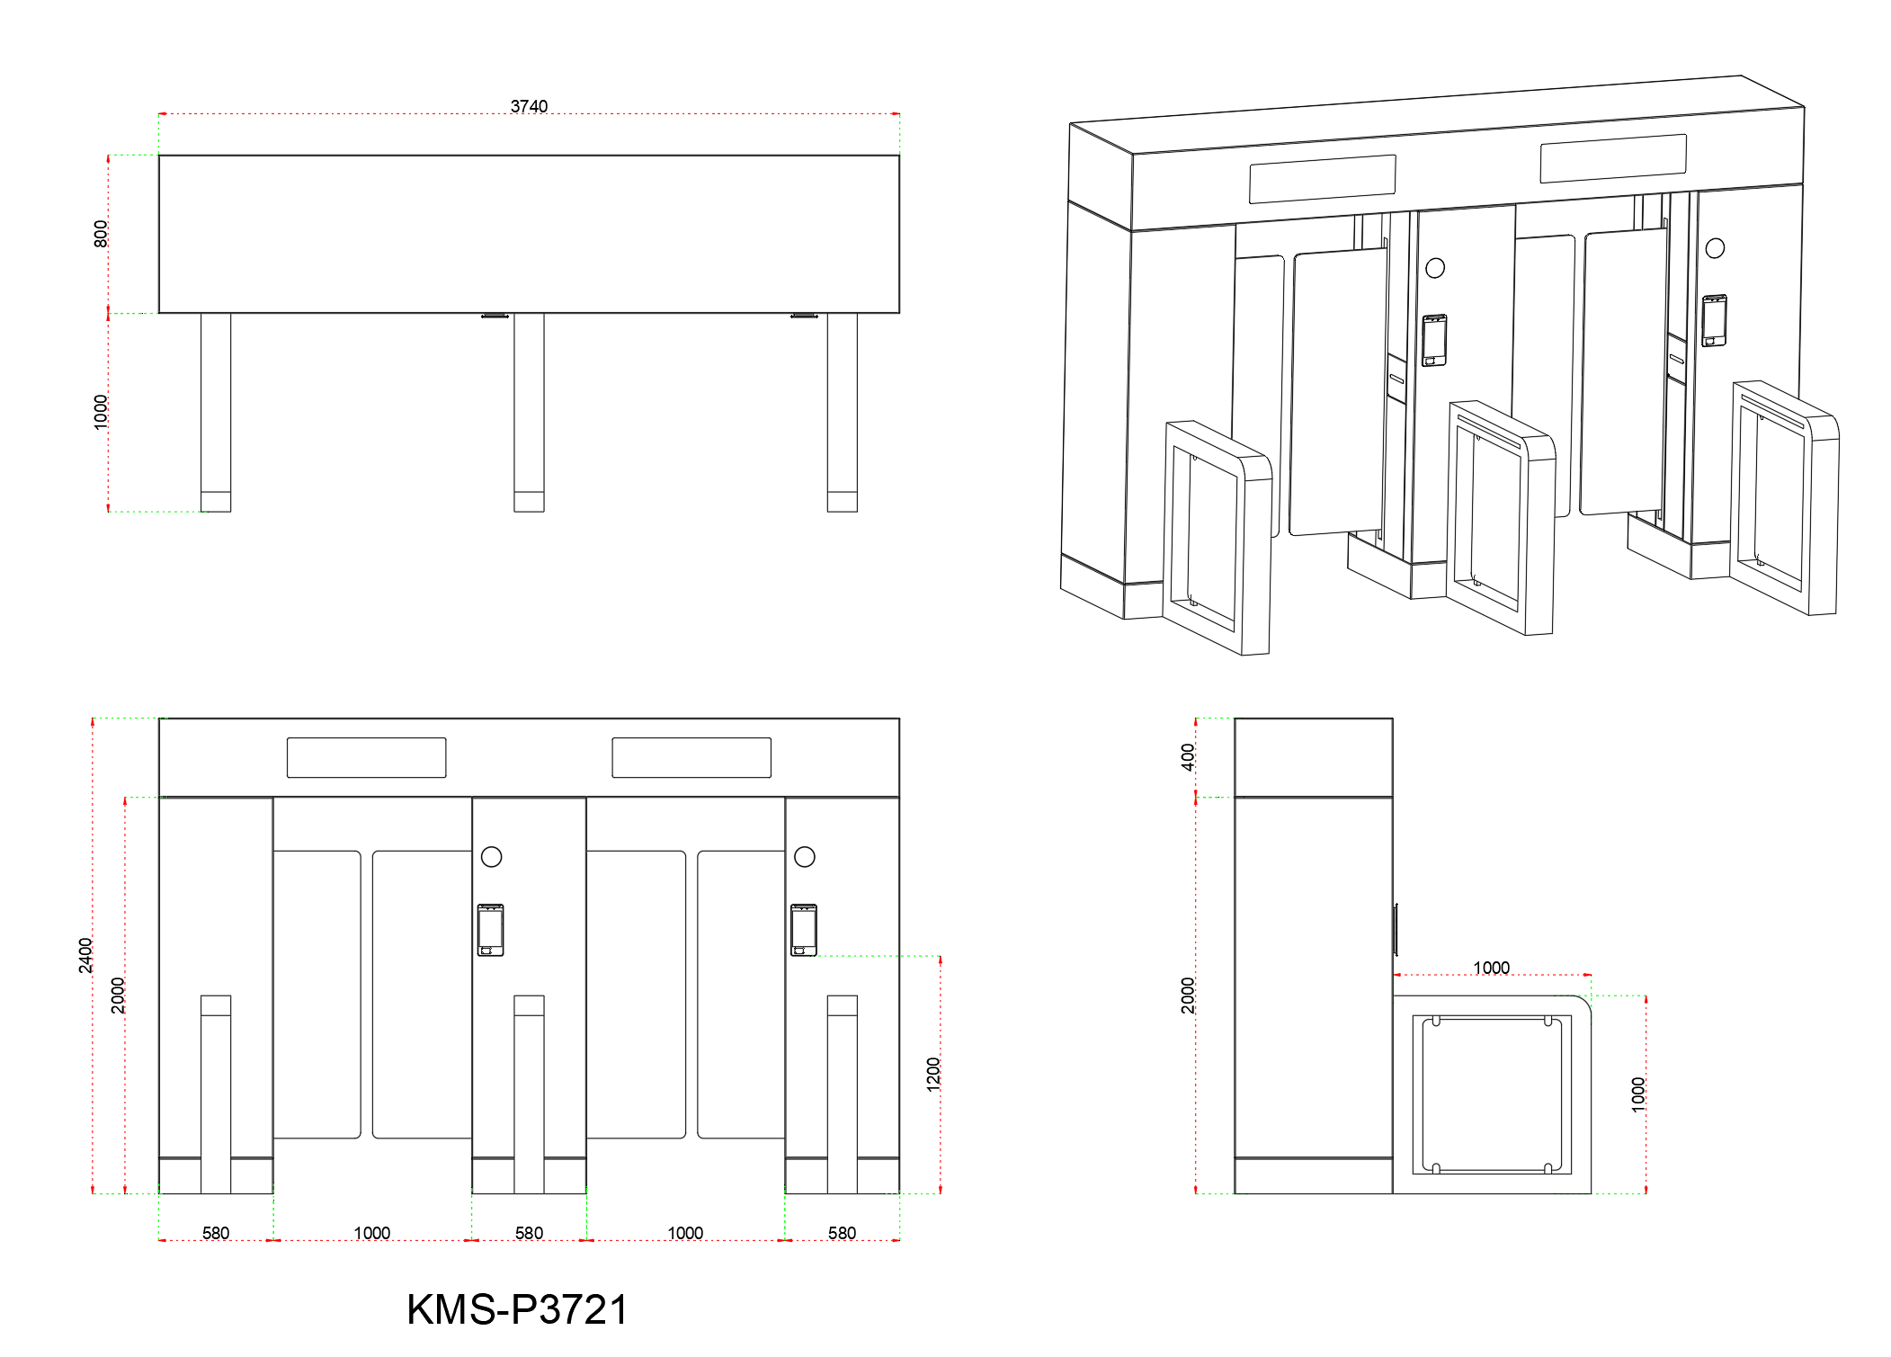

Product Features:
◇ Features fault self-diagnosis and alarm alerts, facilitating user maintenance and operation;
◇The operating status of the programmable device can be monitored via the built-in small control panel on the main board;
◇The motherboard settings are operated via an LCD display with Chinese-language interface, offering convenience and efficiency.
◇Fire Mode Setting: When the gate encounters an emergency situation, it activates fire mode, triggering an alarm and automatically opening the gate.
◇Anti-clamping function: If resistance is encountered during the arm recovery process, the device automatically rebounds or the motor stops operating within a specified time frame, with precise force control.
The degree is very small (≤2 kg);
◇ Sound and light alarm functions: includes unauthorized intrusion detection and tailgating alerts;
◇ Anti-slip function: The swing arm automatically locks when no gate opening signal is received.
◇Scalable arm synchronization function;
◇The system features an automatic reset function: if no vehicle passes through within the specified time after the gate opens, the user's current passage permission will be automatically revoked.
By default, the system automatically resets after 10 seconds when enabled.
◇The passage automatically opens after power outage and closes upon power restoration;
◇ Compatible with various card readers;
◇ allows one-way or two-way control of personnel entry and exit;
◇ Remote control and management can be performed directly via the management computer;

