Intelligent Sliding Gate

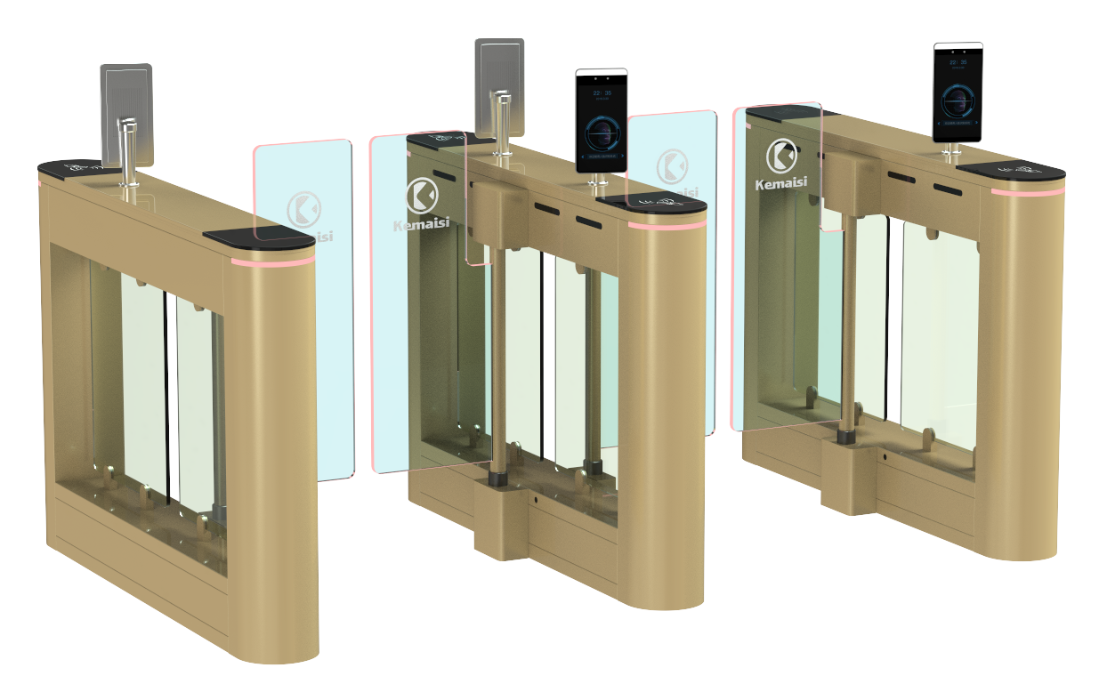

Product Description: The KMS-B8503 Intelligent Turnstile is a high-tech solution designed for intelligent management of personnel access points, representing an upgraded version of the standard smart turnstile. Featuring precision engineering, comprehensive functionality, and premium quality, it is primarily intended for high-end environments such as residential complexes, schools, gyms, tourist attractions, office buildings, hotels, subway stations, ports, and clubs. This device seamlessly integrates mechanical components, electronic systems, microprocessor control, and various identity recognition technologies, ensuring compatibility with IC cards, ID cards, barcode cards, fingerprint scanners, and other card-based identification devices. By incorporating optional identity recognition systems along with reliable security protection mechanisms, alarm systems, and directional indicators, it enables coordinated intelligent control and management of access channels.

outline dimension ：
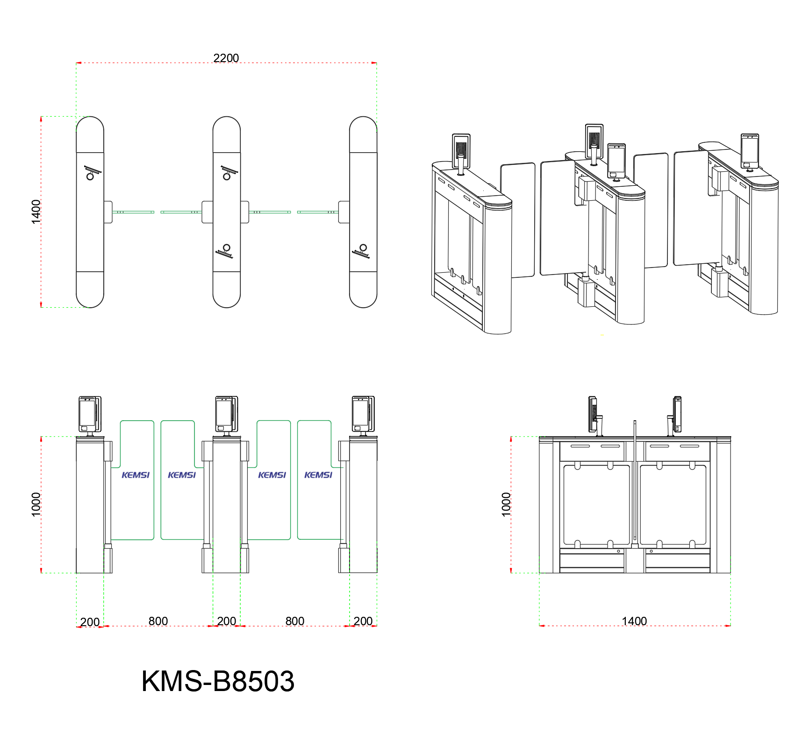

functional characteristics ：
◇ Features built-in fault self-diagnosis and alarm alerts, facilitating user maintenance and operation;
◇The operating status of the programmable device can be monitored via the built-in small control panel on the main board;
◇The motherboard settings are operated via an LCD display with Chinese-language interface, offering convenience and efficiency.
◇Fire Mode Setting: When the gate encounters an emergency situation, it activates fire mode, triggering an alarm and automatically opening the gate.
◇Memory Function: The turnstile accurately records both the number of card swipes and pedestrian crossings when operating continuously, significantly reducing pedestrian transit time.
◇Network-based remote operation: The turnstile can be controlled remotely via the network, facilitating direct communication with customers.
◇Passcode configuration: The gate requires remote password locking.
◇Anti-clamping function: When encountering resistance during arm repositioning, the mechanism automatically rebounds or the motor stops operating within a specified time frame with minimal force (≤2 kg).
◇ Sound and light alarm functions: includes unauthorized intrusion detection and tailgating alerts;
◇ Anti-slip function: The swing arm automatically locks when no gate opening signal is received.
◇Scalable arm synchronization function;
◇ Features an automatic reset function: if no vehicle passes within the specified time after the gate opens, the system will automatically revoke the user's access permission. By default, the system resets automatically after 10 seconds of operation.
◇The passage automatically opens after power outage and closes upon power restoration;
◇ Compatible with various card readers;
◇ allows one-way or two-way control of personnel entry and exit;
◇ Remote control and management can be performed directly via the management computer;

technical parameter ：
◇Product Model: KMS-B8503
◇External dimensions: 1400*200*1000 mm
◇Retractable arm length: 350 mm
◇ Passage width: 550–1000 mm
◇Weight: 40–65 kg
◇Case material: 304 stainless steel; top cover thickness: 1.5 mm; side panels: 1.2 mm thick or 201 stainless steel with baked finish
◇Power supply voltage: AC 220 ±10% V, 50 Hz
◇Driving motor: Brushed/Brushless DC motor (20W/24V)
◇Input interface: Dry contact signal, 12V level signal, or a 12V pulse signal with a pulse width>100ms and a drive current>10mA
◇Standard service life: 5 million cycles
◇Communication interface: RS232 standard
◇LED indicator lights: 2
◇Card reader window: 2
◇ Maintenance access ports: 2
◇Throughput: 30–40 people/min in continuous open mode; 20–30 people/min in continuous closed mode
◇Gate opening/closing time: 1 second
◇Time required to enter the passable state after power-on: 5 seconds
◇Working environment: Indoor or outdoor (under shelter); Temperature: -25°C to 70°C
◇ Infrared Cross-Beam: 4 pairs
Relative humidity: ≤90%, no condensation
This turnstile supports multiple authentication methods including fingerprint, facial recognition, card swiping, password, second-generation ID card, QR code, iris recognition, and palm print recognition.

