Speed Gate

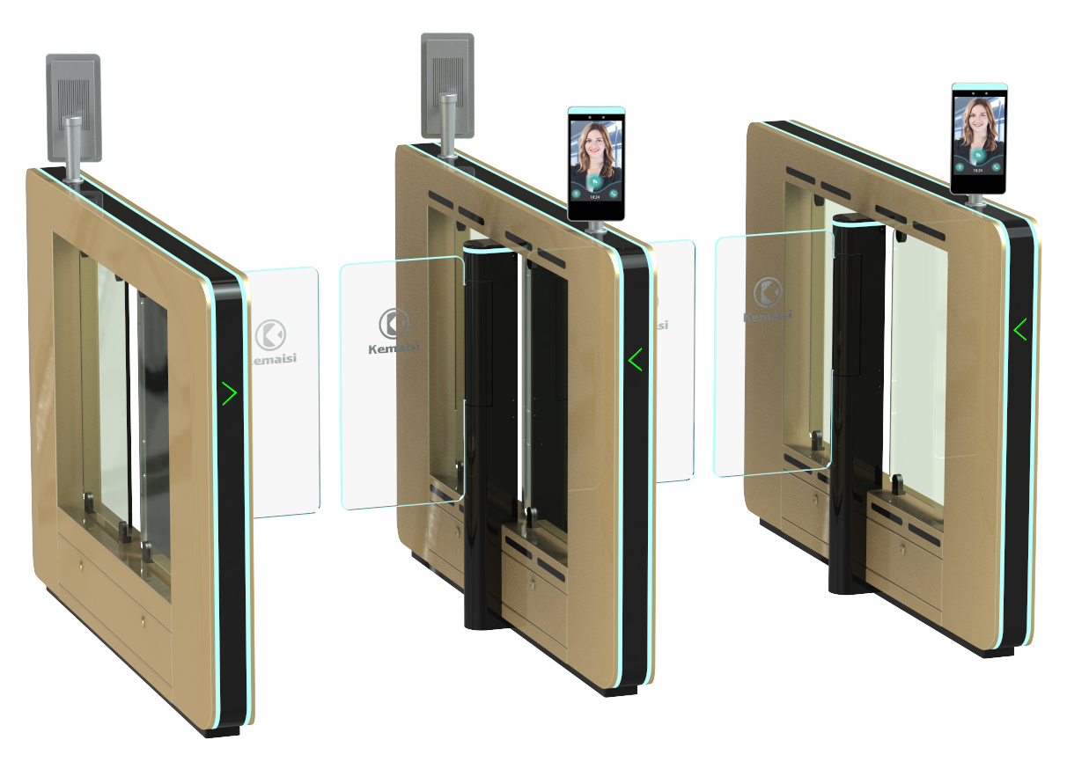

Product Description: The Speed Gate KMS-T5526 is a high-tech product designed for intelligent management of personnel access channels, representing an upgraded version of smart swing gates and flap gates. Featuring precision engineering, comprehensive functionality, and premium quality, it is primarily used in upscale settings such as residential complexes, schools, gyms, tourist attractions, smart buildings, hotels, subway stations, docks, and clubs. This equipment seamlessly integrates mechanical, electronic, microprocessor-based control systems with various identity authentication technologies, supporting multiple access authorization methods including fingerprint, facial recognition, card swiping, password entry, second-generation ID card verification, QR code scanning, iris recognition, and palm print identification.

Product Parameter ：

1. Input: AC 110V–220V Frequency: 50 Hz

I. Power supply voltage:
2、 output ：DC24V8.8A
1. Switch signal

II. Control Signal:
2、RS232
III. Infrared Sensor: PNP/NPN
IV. Motor: Brushless motor/Servo motor + Internal precision differential encoder Power: 100W
V. Door Opening After Power Loss: When power is cut off, the passage remains unbraked and can be manually pushed open (or a battery may be added).
VI. Maximum rotational torque (N·m): rated torque 19 N·m, maximum overload torque 80 N·m
VII. Collisions Prevention Brake: 100 N·m
8. Gate opening/closing speed: 600–1500 mm per channel (0.3–1 second); slower speed for wider channels (consult before finalizing width adjustments).
9. Traffic Light Signals: Green light indicates通行; red light indicates prohibition of passage.
X. Voice Prompt: Voice/Bell
XI. Current Prevention: Present
XII. Gate Synchronization: CAN
13. Power Supply: Two power supplies (24V/8.8A) per channel group
14. Throughput rate: 25–35 passengers per minute.
15. Working environment temperature: -30°C to 60°C
16. Service Life: Over 5 million consecutive open-close cycles.
17. Work noise: below 60 decibels.
18. Relative humidity: ≤95%, no condensation.

Configuration List:

product model | KMS-T5526
Case material | Domestic standard 304 stainless steel with thicknesses of 1.5 mm + 1.2 mm; 201 stainless steel coated with paint.
product size | 1500*120*1000mm
gangway width | 600-1500mm
infrared | 6 pairs (Jietek)
source | 8.8A 24V (Mingwei)
Arm swing material | Stainless steel swing door/Acrylon swing door (optional)
working voltage | AC220V±10%/50HZ
plant capacity | 80W
service environment | Indoor and outdoor
end-use temperature | Temperature range: -10°C to 70°C; Relative humidity: ≤95%; No condensation.
Input Interface | Relay dry contact signal or a 12V pulse signal with a pulse width ≥100 ms
CI | RS485 standard: Distance ≤1200 meters

product size ：
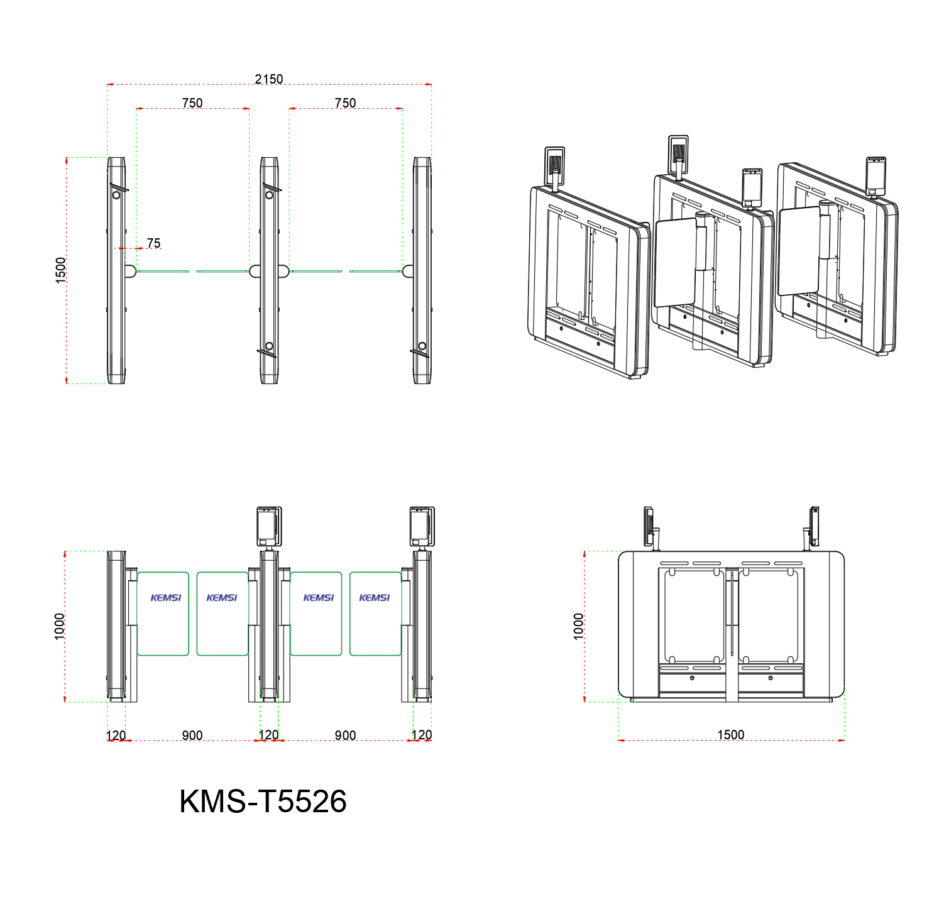

Product Features:
◇ Features fault self-diagnosis and alarm alerts, facilitating user maintenance and operation;
◇The operating status of the programmable device can be monitored via the built-in small control panel on the main board;
◇The motherboard settings are operated via an LCD display with Chinese-language interface, offering convenience and efficiency.
◇Fire Mode Setting: When the gate encounters an emergency situation, it activates fire mode, triggering an alarm and automatically opening the gate.
◇Anti-lock mechanism: If resistance occurs during arm repositioning, the system automatically rebounds or stops motor operation within a specified time frame with minimal force (≤2 kg).
◇ Sound and light alarm functions: includes unauthorized intrusion detection and tailgating alerts;
◇ Anti-slip function: The swing arm automatically locks when no gate opening signal is received.
◇Scalable arm synchronization function;
◇The system features an automatic reset function: if no vehicle passes through within the specified time after gate opening, the user's passage permission will be automatically revoked. By default, the system resets automatically 10 seconds after activation.
◇The passage automatically opens after power outage and closes upon power restoration;
◇ Compatible with various card readers;
◇ allows one-way or two-way control of personnel entry/exit;
◇ Remote control and management can be performed directly via the management computer;

