Intelligent Wing Gate

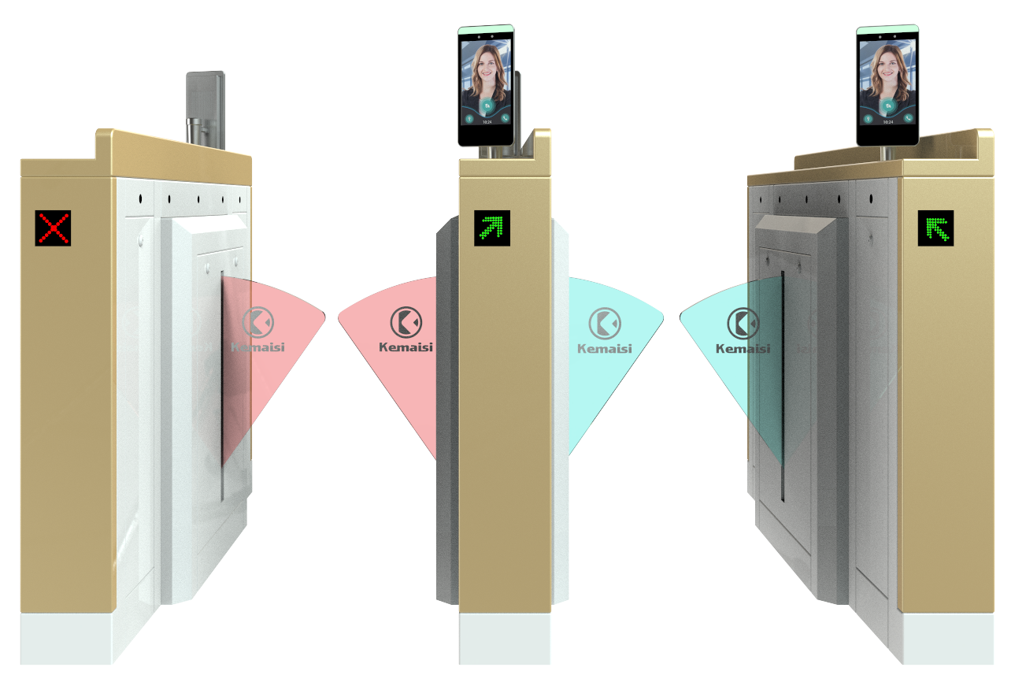

Product Description: The Intelligent Wing Gate KMS-Y7661 is a high-tech product designed for intelligent management of personnel access channels, representing an upgraded version of smart three-roll gates and swing gates. Featuring precision engineering, comprehensive functionality, and premium quality, it is primarily used in upscale settings such as high-end residential communities, smart buildings, hotels, subway systems, ports, and clubs. This equipment seamlessly integrates mechanical, electronic, microprocessor control technologies with various identity recognition systems, supporting compatibility with IC cards, ID cards, barcode cards, fingerprint scanners, and other card-based identification devices. By incorporating optional identity verification systems along with reliable security protection mechanisms, alarm systems, and directional indicators, it enables coordinated intelligent control and management of access points.

outline dimension ：
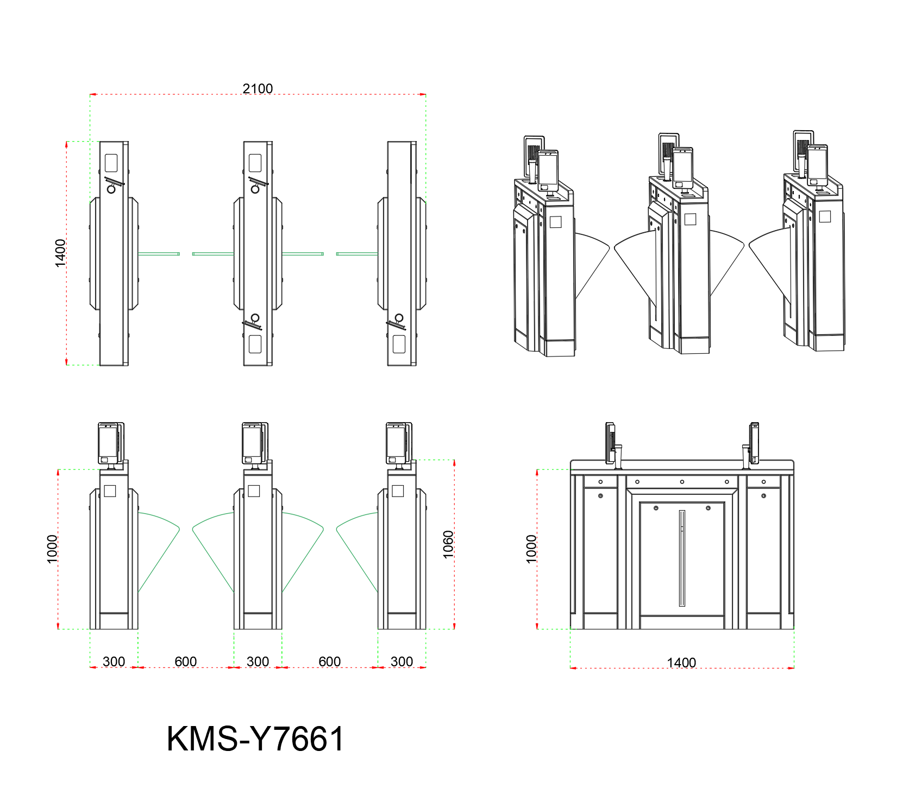

Standard Product Features:
◇ Features fault self-diagnosis and alarm alerts, facilitating user maintenance and operation;
◇The operating status of the programmable device can be monitored via the built-in small control panel on the main board;
◇The motherboard settings are operated via an LCD display with Chinese-language interface, offering convenience and efficiency.
◇Fire Mode Setting: When the gate encounters an emergency situation, the fire mode is activated, triggering an alarm and automatically opening the gate.
◇Memory Function: The turnstile accurately records both the number of card swipes and pedestrian crossings when operating continuously, significantly reducing pedestrian transit time.
◇Remote network operation: The turnstile can be operated remotely via the network, facilitating direct communication with customers.
◇Set the access gate password; the gate requires remote password locking.
◇Anti-lock mechanism: If resistance occurs during arm repositioning, the mechanism automatically rebounds or the motor stops operating within a specified time frame with minimal force (≤2 kg).
◇ Sound and light alarm functions: includes unauthorized intrusion and tailgating alerts;
◇ Anti-slip function: The swing arm automatically locks when no gate opening signal is received.
◇Scalable arm synchronization function;
◇The system features an automatic reset function: if no vehicle passes through within the specified time after gate opening, the user's passage permission will be automatically revoked. By default, the system resets automatically 10 seconds after activation.
◇The passage automatically opens after power outage and closes upon power restoration;
◇ Compatible with various card readers;
◇ allows one-way or two-way control of personnel entry and exit;
◇ Remote control and management can be performed directly via the management computer;

Standard technical parameters:
◇Product Model: KMS-Y7661
◇External dimensions: 1400*300*1060 mm
◇Retractable arm length: 270 mm
◇Passage width: 550–600 mm
◇Weight: 50–85 kg
◇Case material: Domestic standard 304 stainless steel; top cover thickness: 1.5 mm; side panel thickness: 1.2 mm
◇Power Supply Voltage: AC 220 ±10% V, 50 Hz
◇Driving Motor: Brushed/brushless DC motor (20W/24V)
◇Input interface: Dry contact signal, 12V level signal, or a 12V pulse signal with a pulse width>100ms and drive current>10mA
◇Standard service life: 5 million cycles
◇Communication interface: RS232 standard
◇LED indicator lights: 2
◇Card reader window: 2
◇ Maintenance access ports: 2
◇Throughput: 30–40 people/min in continuous open mode; 20–30 people/min in continuous closed mode
◇Gate opening/closing time: 1 second
◇Time required to enter traffic flow after power-on: 5 seconds
◇Working environment: Indoor or outdoor (under shelter); Temperature: -25°C to 70°C
◇ Infrared Transverse Detection: 3 pairs
Relative humidity: ≤90%, no condensation
This system supports multiple authentication methods including fingerprint recognition, facial recognition, card swiping, passwords, second-generation ID cards, and QR codes.

