
KMS-G6511
Single-channel three-roll barrier gate
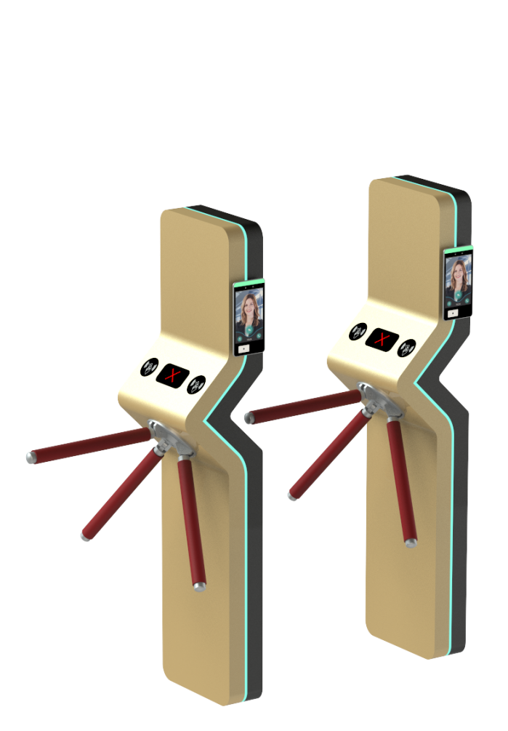

The KMS-G6511 is designed for strictly regulated areas, effectively preventing unauthorized personnel tracking. When individuals pass through the turnstile, access-controlled turnstiles can deny entry to unauthorized persons; if permission is granted, the turnstile automatically releases them. It is widely used for access control at basketball arenas, gyms, tourist attractions, amusement parks, construction sites, factories, residential communities, campuses, and other venues.

Order model:

model | Material Code | remarks
KMS-G6511-120/Pg-Dm55 | 202600493 | The facial device requires a separate accessory.
KMS-G6511-120/M-Dm55-I | 202600494 | IC card reader with built-in 2602X-AI motherboard and card reader kit

product features ：

- The movement features a unique mechanical structure, with a rational and reliable design that produces low noise, ensures smooth operation, and offers a long service life.
- It features bidirectional passage capability, with the gate rod steering available in both two-way and one-way configurations.
- After a power outage, the door unlocks automatically and switches to mechanical mode, allowing personnel to enter and exit freely while meeting fire safety requirements.
- A bidirectional arrow indicator shows the traffic status.
- It features an automatic reset function: once permission to pass through the gate is granted, if the user fails to pass within the specified time, the full-height gate automatically cancels the permission and returns to its initial state.
- Waterproof, sun-resistant, cold-resistant, and heat-resistant.
- It can be expanded into an automated identity recognition system, enabling functions such as access control and attendance management.
- Support memory modes, such as swiping the valid card five times and passing through five people.
- The passage delay time can be adjusted via the dial code.

technical parameter ：
product model | KMS-G6511
physical interface | I/O,RS485
Passage Rate | 30 people per minute; the actual throughput rate is influenced by personnel availability and traffic patterns.
Channel width | 550-600mm
Single rotation angle | 120°
Door panel material | 304 stainless steel / 201 stainless steel, painted
Channel Box Body | SUS304 stainless steel/stainless steel 201 painted; wall thickness: 1.2 mm; 38mm steel pipe
size | 420mm*320*1700mm
input voltage | 220V±10%
working temperature | -20℃~65℃
Working humidity | 10%-95% (in the absence of condensed water droplets)
work environment | Indoor and outdoor
plant capacity | 50W

product size ：
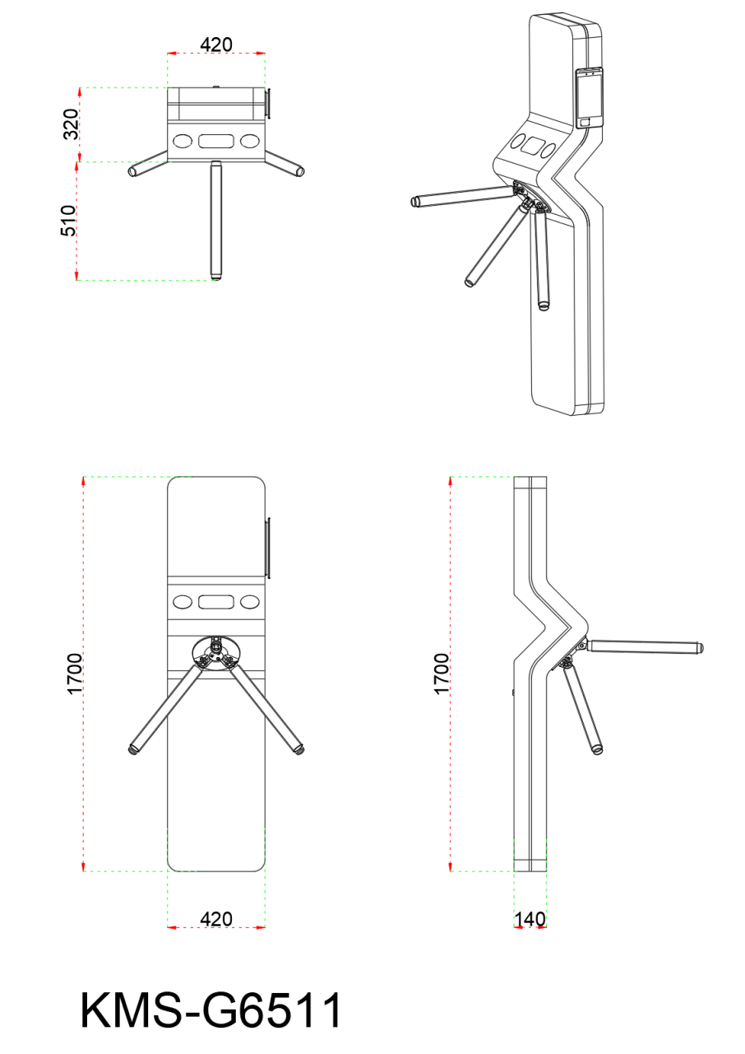

matters need attention ：

One of the primary components of pedestrian walkway products is stainless steel, which exhibits excellent corrosion resistance (ability to resist atmospheric oxidation) and resistance to corrosion in acidic, alkaline, or saline environments. However, its corrosion resistance varies depending on factors such as its chemical composition and operating conditions. To maintain the aesthetic appearance of stainless steel and extend its service life, regular maintenance is essential.
The maintenance precautions are as follows:
- Different specifications of stainless steel should be selected depending on the operating environment. In general conditions, 304 stainless steel is suitable; for coastal areas or chemical plants, 316 stainless steel is recommended.
- Keep the product surface clean and dry.
- When contaminants appear on the product surface, they can be cleaned using non-woven fabric and alcohol.
- When rust spots appear on the product surface, use a cleaning cloth (never employ a wire scrub ball) to wipe back and forth along the grain lines of the rust until complete removal is achieved. Subsequently, apply a non-woven cloth and stainless steel maintenance agent for a thorough final clean.
- The entire turnstile should be regularly maintained by wiping with non-woven fabric and stainless steel cleaning agent. Under normal circumstances, maintenance is recommended once per month; in harsh environments (e.g., coastal areas or chemical plants), weekly maintenance is advised.

